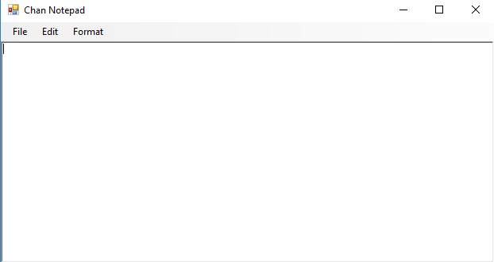

Chan Notepad Ver. 1(Visual Basic)

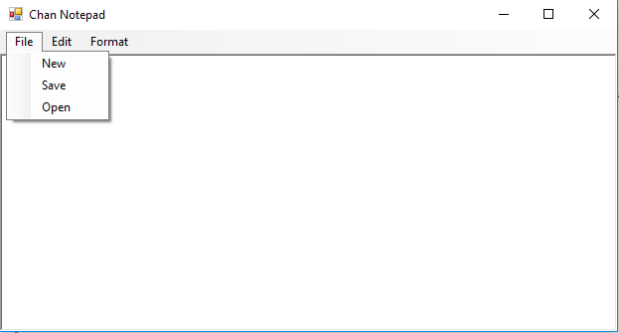

File

New

RichTextBox1.Clear()

Save

Try

Dim dlg As SaveFileDialog = New SaveFileDialog

dlg.Title = "Save"

dlg.Filter = "Rich Text Files (\*.rtf)|\*.rtf"

If dlg.ShowDialog() = System.Windows.Forms.DialogResult.OK Then

RichTextBox1.SaveFile(dlg.FileName, RichTextBoxStreamType.RichText)

End If

Catch ex As Exception : End Try

Open

Try

Dim dlg As OpenFileDialog = New OpenFileDialog

dlg.Title = "Open"

dlg.Filter = "Rich Text Files (\*.rtf)|\*.rtf"

If dlg.ShowDialog() = System.Windows.Forms.DialogResult.OK Then

RichTextBox1.LoadFile(dlg.FileName)

End If

Catch ex As Exception : End Try

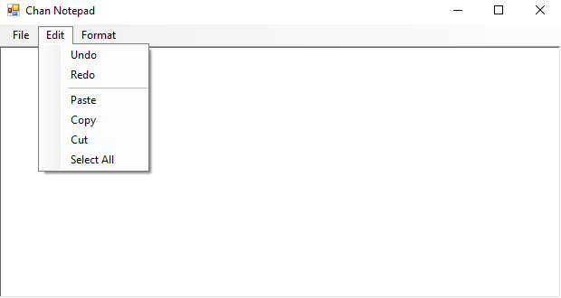

Edit

Undo

RichTextBox1.Undo()

Redo

RichTextBox1.Redo()

Paste

RichTextBox1.Paste()

Copy

RichTextBox1.Copy()

Cut

RichTextBox1.Cut()

Select All

RichTextBox1.SelectAll()

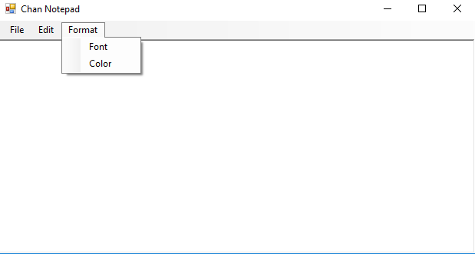

Format

Font

Try

Dim dlg As FontDialog = New FontDialog

dlg.Font = RichTextBox1.Font

If dlg.ShowDialog = System.Windows.Forms.DialogResult.OK Then

RichTextBox1.Font = dlg.Font

End If

Catch ex As Exception : End Try

Color

Try

Dim dlg As ColorDialog = New ColorDialog

dlg.Color = RichTextBox1.ForeColor

If dlg.ShowDialog = System.Windows.Forms.DialogResult.OK Then

RichTextBox1.ForeColor = dlg.Color

End If

Catch ex As Exception : End Try